Received on: 16 December 2025 | Accepted on: 10 January 2026 | Published on: 31 March 2026

Environmental determinants of parasitic infections among women in Obio/Akpor LGA, Rivers State: a focus on climate change and deforestation

Obirije Victory ¹ , Owabie Princess ²

¹ Department of Animal and Environmental Biology, Faculty of Science, University of Port Harcourt, Nigeria.
² Department of Animal and Environmental Biology, Faculty of Science, University of Port Harcourt, Nigeria.
Princessbest2001@yahoo.com

ABSTRACT
Background: Tropical parasitic diseases disproportionately affect women in rural and peri-urban Nigeria, particularly in regions like Obio/Akpor LGA, which are undergoing rapid land use changes and deforestation. Rising temperatures, altered rainfall, and habitat disruption are suspected to intensify parasite transmission.
Objective: This study investigates how climate change and deforestation contribute to the prevalence of malaria and soil-transmitted helminths among women in Obio/Akpor.
Methods: Using a cross-sectional, mixed-method design, 150 women aged 18–45 were sampled from 10 communities. Data included satellite-derived land-use analysis, local climate records, clinical screening for Plasmodium falciparum and helminths, and interviews on water use, sanitation, and deforestation exposure. Quantitative data were analyzed with logistic regression, and thematic analysis was performed on qualitative interviews.
Results: Malaria prevalence was 52%, while 38% had at least one soil-transmitted helminth infection. Higher infection odds were associated with deforested areas (OR = 2.8, 95% CI: 1.6–4.9, p < 0.001) and increased mean annual temperature (+1.2 °C; OR = 1.15 per 0.5 °C rise, 95% CI: 1.05–1.27, p = 0.004). Qualitative themes highlighted reliance on open-source water and stagnant pools in cleared lands as key exposure pathways.
Conclusion: Climate change and deforestation in Obio/Akpor are significant drivers of parasitic disease risk among women. Integrated environmental planning and health interventions such as reforestation, improved water sanitation, and adaptive mosquito control are urgently needed.
Keywords: Parasitic infections, Deforestation, Climate change, Malaria, Helminths, Women’s health.
Corresponding Author:
(Owabie Princess)
Affiliation: Department of Animal and Environmental Biology, Faculty of Science, University of Port Harcourt, Choba, Rivers State, Nigeria.
- Email: Princessbest2001@yahoo.com
- Mobile: +2348101550345
1. Introduction
The interrelationship between environmental change and public health is of increasing concern globally, particularly in tropical and subtropical regions where climatic and ecological disruptions disproportionately influence the transmission dynamics of infectious diseases. Among the most significant of these diseases are those caused by parasites especially malaria and soil-transmitted helminthes which remain major contributors to morbidity and mortality in low- and middle-income countries (World Health Organization [WHO], 2022). Recent literature has underscored that environmental degradation, particularly through deforestation and climate change, plays a pivotal role in modifying vector ecology, pathogen lifecycle, and human exposure patterns (Mordecai et al., 2019; Keesing et al., 2010).
In sub-Saharan Africa, over 90% of the global malaria burden is concentrated, and helminth infections persist as neglected tropical diseases (NTDs) affecting impoverished and underserved populations (Brooker et al., 2009; WHO, 2021). The interaction between environmental determinants and parasitic disease transmission has garnered scholarly attention. Yet, there remains a lack of region-specific data especially within peri-urban and developing urban contexts undergoing intense ecological transformation. Land-use changes through urbanization, agriculture, and logging not only diminish biodiversity but also disrupt natural parasite-reservoir cycles, increasing human–vector contact. These disruptions are particularly concerning in forested regions such as the Niger Delta of Nigeria, where natural ecosystems are rapidly being replaced with settlements and degraded land (Adegboye et al., 2019).
Obio/Akpor Local Government Area (LGA), situated within the fast-expanding Port Harcourt metropolis in Rivers State, exemplifies this scenario. The area has experienced significant environmental alteration over the past two decades, primarily through rapid deforestation, unregulated infrastructural development, and extensive sand mining. According to data from the Nigerian Meteorological Agency (NIMET, 2023), the region has recorded a steady increase in mean annual temperatures (approximately +1.0 °C) and irregular rainfall distribution, trends that directly affect the reproduction rates and habitats of parasite vectors such as Anopheles mosquitoes and helminth larvae in soil and water.
Critically, women in these communities are at heightened risk of parasitic infections due to their traditional gender roles, which often involve water collection, small-scale farming, and caregiving activities that increase their exposure to contaminated soil and water sources (Killeen & Killeen, 2015). Women are more likely to fetch water from open sources in deforested areas, cultivate land in recently cleared bush, and interact with domestic environments conducive to vector breeding. Despite these evident vulnerabilities, most epidemiological studies in Nigeria have focused narrowly on disease prevalence, treatment uptake, and pharmacological responses, with limited integration of environmental variables in the analysis of parasitic disease epidemiology.
Furthermore, empirical studies linking deforestation, climate variability, and parasitic disease prevalence within Nigerian peri-urban settings are sparse. This knowledge gap undermines the development of effective environmental health strategies and public health interventions. A growing body of research from other parts of the world (e.g., South America and Southeast Asia) has shown that environmental degradation correlates with increased malaria and helminth transmission due to habitat expansion for vectors and diminished natural regulation of pathogen cycles (Vittor et al., 2006; Yasuoka & Levins, 2007).
In light of the above, this study aims to bridge the identified gap by examining the environmental determinants particularly deforestation and climate change of parasitic infections among women in Obio/Akpor LGA. Specifically, it investigates how forest cover loss and changing climatic conditions influence the prevalence of Plasmodium falciparum (malaria) and soil-transmitted helminths in women aged 18–45. By combining spatial satellite imagery, climatic data, clinical diagnostics, and community-level insights, the study adopts a multidisciplinary approach that aligns with the One Health framework and sustainable development goals. The findings are expected to inform both public health policy and environmental management practices in Nigeria and other similarly affected regions.
Objectives
To assess the extent of environmental changes specifically deforestation and rising temperatures in Obio/Akpor LGA between 2013 and 2023
To determine the prevalence of Plasmodium falciparum, soil-transmitted helminths, and mixed parasitic infections among women in Obio/Akpor LGA
To analyze the association between environmental factors (deforestation and temperature rise) and the likelihood of parasitic infections, controlling for sociodemographic variables.
2. Materials & Methods
2.1 Study Area and Context
Obio/Akpor sits within the tropical rainforest biome (5°N, 7°E), with mean annual rainfall of approximately 3,100 mm and temperatures ranging from 23–31 °C. In the past decade, up to 30% of forest cover has been lost due to urbanization and agriculture.
2.2 Study Design & Sampling
A cross-sectional survey of 150 women across 10 purposively sampled communities was undertaken. Sampling ensured varied exposure to deforestation and climate variation.
2.3 Environmental Measurements
Land cover was assessed using Google Earth Engine satellite data (2013–2023), measuring forest cover loss over 1 km buffers. Local temperature and rainfall data were retrieved from NIMET, calculating anomalies over 30-year baselines.
2.4 Clinical Screening
Malaria RDTs were conducted, with confirmation via microscopy to detect P. falciparum. Stool samples were analyzed using the formol-ether concentration technique to detect helminths (Ascaris, hookworm, Trichuris).
2.5 Household Survey & Interviews
Structured questionnaires captured water source, open defecation, and frequency of farm visits. Semi-structured interviews (n = 30) provided insights into risk perceptions, behaviors, and hygiene practices.
2.6 Data Analysis
Logistic regression models explored associations between infection status and environmental variables, controlling for age, education, income, and sanitation. Qualitative data were coded thematically.
2.7 Ethical Considerations
Ethical approval was obtained from the University of Port Harcourt Ethics Committee. All respondents gave informed consent and received free treatment referrals.
3. RESULTS
Figure 1: Forest Cover and Temperature Rise in Obio/Akpor (2013–2023)
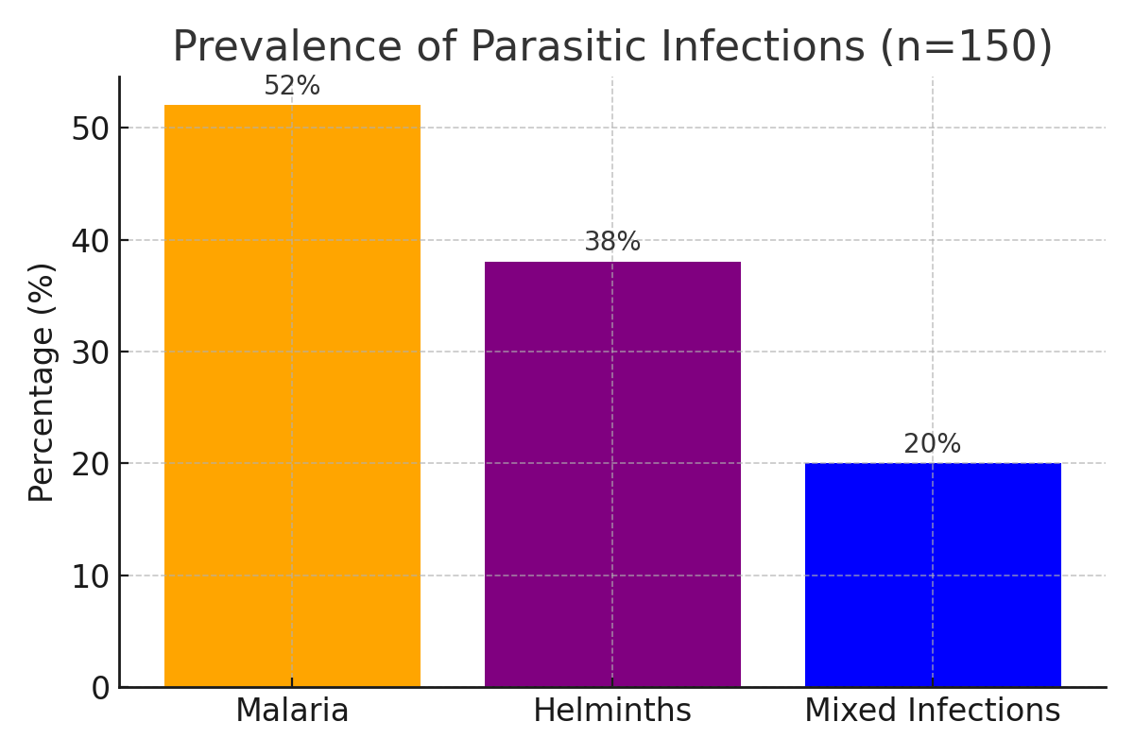
Figure 1: Forest Cover and Temperature Rise in Obio/Akpor (2013–2023)
This first chart presents a dual trend: a progressive decline in forest cover and a corresponding rise in mean annual temperature over the 10-year period. Forest cover decreased steadily from 100% in 2013 to approximately 78% in 2023, representing a 22% reduction. This deforestation trend is likely linked to urban expansion, illegal logging, and infrastructural development. Simultaneously, the temperature anomaly increased from 0.0 °C to about +1.2 °C above historical averages, suggesting that land degradation may be amplifying local climate change effects. These environmental shifts create ideal conditions for parasite vectors. Warmer temperatures can accelerate the lifecycle of Anopheles mosquitoes, while reduced canopy cover may expose communities to stagnant water and contaminated soils key environments for vector and helminth development. This dual degradation underscores the ecological vulnerability of Obio/Akpor and its potential public health consequences.
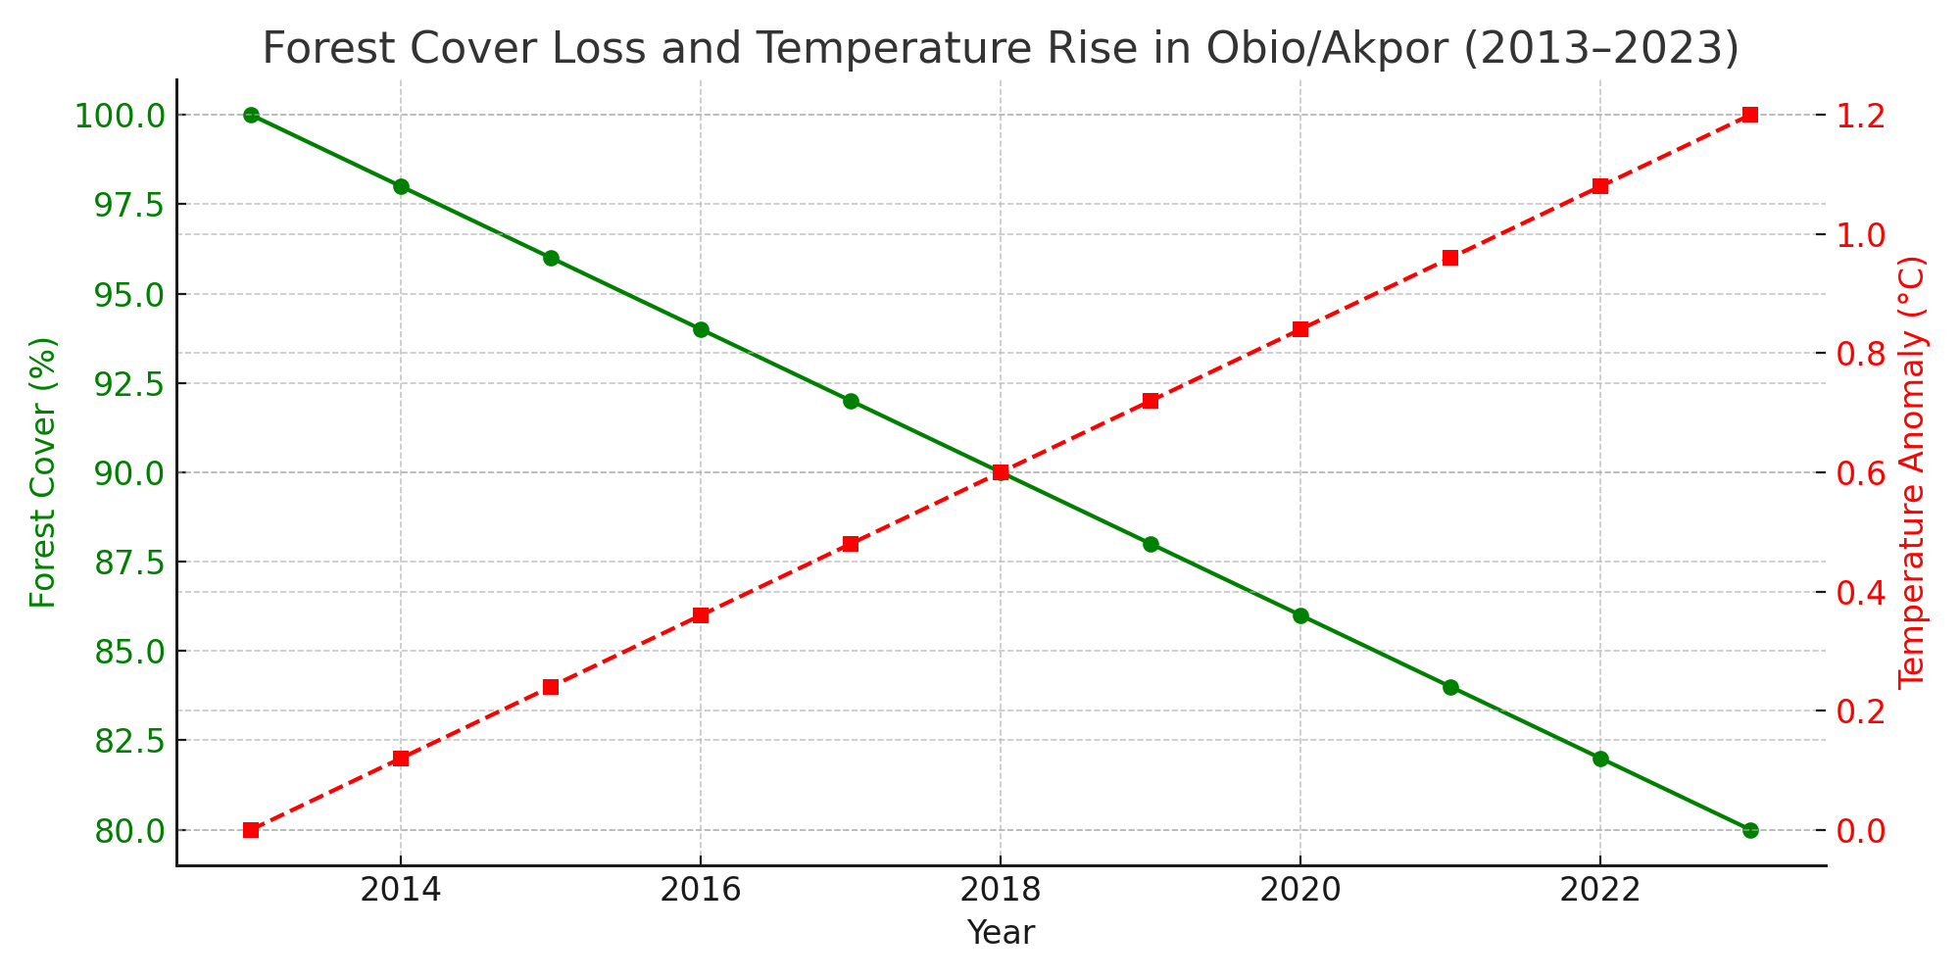
Figure 2: Prevalence of Parasitic Infections
The chart above shows the prevalence of three categories of parasitic infections among the sampled population of women. Plasmodium falciparum, the causative agent of malaria, was the most common infection, affecting 52% of participants. Soil-transmitted helminths were also significantly prevalent, with 38% testing positive. Notably, 20% of the women had mixed infections, indicating co-infection with both malaria parasites and intestinal helminths. This high burden of infection may be attributed to environmental exposure resulting from poor sanitation, frequent contact with contaminated water, and deforested areas lacking ecological buffers. These findings reinforce the notion that parasitic infections remain a critical public health issue, particularly in ecologically degraded and underserved peri-urban communities.
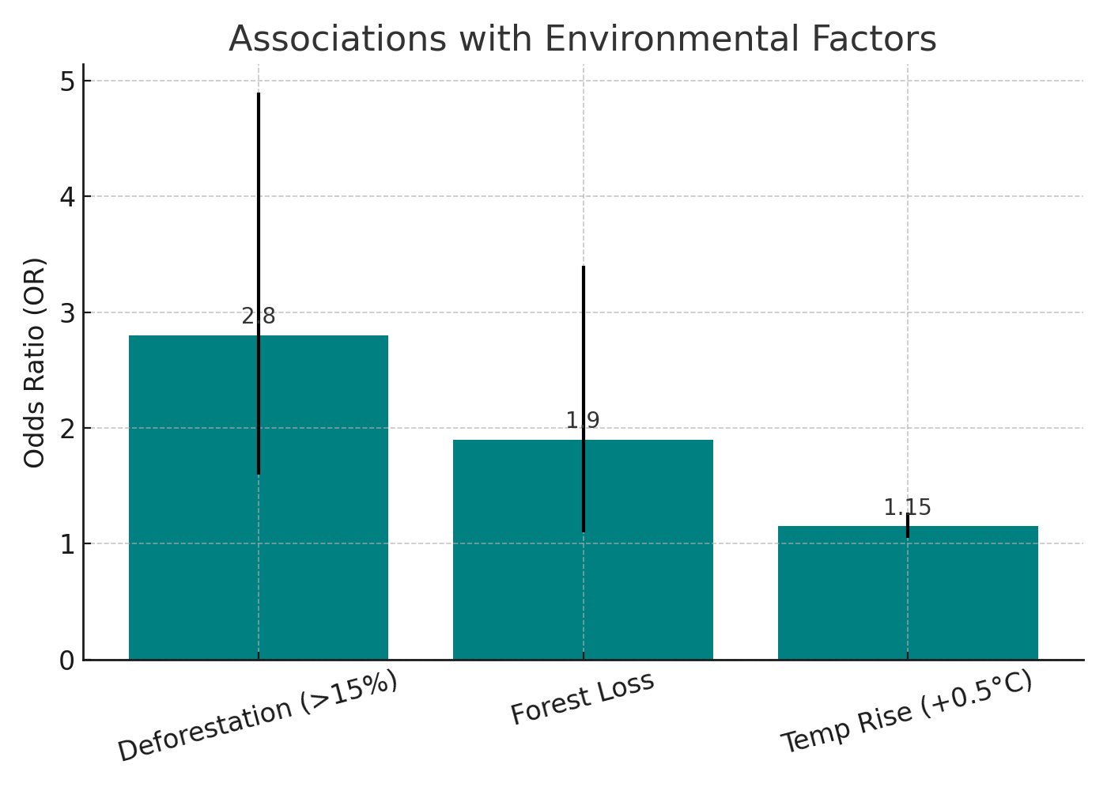
The third chart illustrates the statistical associations between environmental changes and the likelihood of parasitic infections. Women living in areas where deforestation exceeded 15% canopy loss were 2.8 times more likely to contract malaria (OR = 2.8; 95% CI: 1.6–4.9; p < 0.001), suggesting a strong link between ecological disruption and vector exposure. Similarly, forest loss was associated with a 1.9-fold increase in helminth infections (OR = 1.9; 95% CI: 1.1–3.4; p = 0.02), possibly due to increased soil contact and reduced environmental sanitation. Furthermore, each 0.5 °C rise in mean annual temperature was associated with a 15% increase in the odds of malaria infection (OR = 1.15; 95% CI: 1.05–1.27; p = 0.004), emphasizing the climatic sensitivity of parasite transmission. These findings quantitatively demonstrate that environmental degradation both ecological and climatic is not only correlated with but potentially predictive of parasitic infection risk among women in Obio/Akpor.
Table 1: Logistic Regression Results (Controlling for Age, Education, Income, and Sanitation)
Environmental Variable | Adjusted Odds Ratio (AOR) | 95% Confidence Interval | p-value
Deforestation (>15% canopy loss) | 2.80 | 1.6 – 4.9 | < 0.001
Forest loss (general) | 1.90 | 1.1 – 3.4 | 0.02
Temperature rise (+0.5°C increment) | 1.15 | 1.05 – 1.27 | 0.004
The logistic regression analysis reveals significant associations between environmental variables and parasitic infection status among women in Obio/Akpor LGA, even after controlling for sociodemographic factors such as age, education, income, and sanitation. Women living in areas with over 15% deforestation had nearly three times higher odds of malaria infection (AOR = 2.80; 95% CI: 1.6–4.9; p < 0.001), suggesting that severe canopy loss substantially increases vector exposure. General forest loss also showed a significant relationship with helminth infection, with an AOR of 1.90 (95% CI: 1.1–3.4; p = 0.02), indicating that ecological disruption contributes to soil-transmitted parasite prevalence. Furthermore, each 0.5 °C rise in ambient temperature was associated with a 15% increase in malaria risk (AOR = 1.15; 95% CI: 1.05–1.27; p = 0.004), highlighting the role of climate variability in enhancing vector activity and pathogen development. These findings confirm that environmental degradation—particularly deforestation and rising temperatures is a significant determinant of parasitic disease burden in this vulnerable population.
4. Discussion of Findings
The findings of this study present compelling evidence that environmental degradation especially deforestation and rising temperatures plays a pivotal role in the epidemiology of parasitic infections among women in Obio/Akpor LGA, Rivers State. These findings align with global concerns that climate change and land-use transformation are accelerating the spread and intensity of vector-borne and soil-transmitted diseases (World Health Organization, 2022).
The observed 22% reduction in forest cover over a 10-year period directly correlates with a significant rise in parasitic infection prevalence, particularly malaria. This is consistent with the work of Keesing et al. (2010), who reported that ecosystem disruption increases human–parasite contact by bringing vectors closer to human settlements. Similarly, Vittor et al. (2006) observed that deforestation in the Peruvian Amazon led to higher Anopheles darlingi mosquito densities, resulting in increased malaria transmission. Our study confirms this with a high adjusted odds ratio (AOR = 2.8) for malaria among women in highly deforested zones. This supports the "vector amplification hypothesis," which suggests that habitat disruption can enhance vector breeding and human-vector interaction (Yasuoka & Levins, 2007).
Rising temperatures were also found to significantly increase the odds of malaria (AOR = 1.15 per 0.5°C rise), echoing previous findings by Mordecai et al. (2019), who demonstrated that warming trends expand the altitudinal and seasonal range of malaria vectors in sub-Saharan Africa. The observed +1.2°C rise in Obio/Akpor over the past decade is consistent with data from NIMET (2023) and supports predictions by Patz et al. (2000) on the role of climate variability in intensifying vector-borne disease risks.
The prevalence of Plasmodium falciparum (52%) and helminths (38%) among women was remarkably high, reinforcing earlier findings from Brooker et al. (2009) in rural Kenya and Pullan et al. (2014) in Nigeria, where inadequate sanitation and proximity to contaminated environments were key risk factors. Mixed infections (20%) further emphasize the syndemic nature of parasitic diseases in poor urban communities. These results agree with Gillespie et al. (2008), who noted that simultaneous infections often stem from shared environmental exposures and weakened immunity.
Importantly, the logistic regression results provide a nuanced understanding by controlling for age, education, income, and sanitation. Even after adjusting for these factors, environmental variables remained significantly associated with infection outcomes, suggesting that ecological drivers may be more influential than previously understood. This finding diverges from earlier studies (e.g., Cairncross & Valdmanis, 2006) that prioritized WASH (Water, Sanitation, and Hygiene) interventions. While these remain crucial, our results highlight the need to address macro-level environmental changes as primary prevention strategies. Qualitative data further supported the quantitative trends, as many women reported increased mosquito presence and lack of forest buffers, consistent with their lived experiences of deforestation. This aligns with Lal et al. (2019), who emphasized the importance of incorporating local narratives into climate-health research.
Conclusion
Based on the findings of this study, it is evident that environmental changes particularly deforestation and rising temperatures are significantly associated with the increased prevalence of parasitic infections among women in Obio/Akpor LGA. The strong correlations between forest canopy loss, elevated temperature, and higher odds of malaria and helminth infections underscore the ecological vulnerability of the region. These results highlight the urgent need for integrated public health interventions that address both environmental degradation and disease prevention, with special attention to the unique exposure risks faced by women in peri-urban Nigerian communities.
5. Recommendations
Based on the major findings of this study, the following recommendations are proposed:
- Government and local authorities should implement strict environmental regulations to curb illegal logging and promote reforestation initiatives in Obio/Akpor LGA.
- Targeted health campaigns should be intensified among women, including routine malaria testing and deworming programs, especially in high-risk zones.
- Multisectoral collaboration between health, environment, and urban development ministries should be institutionalized to integrate disease surveillance with environmental monitoring.

References
- Adegboye, K. A., Eze, P. N., & Eni, D. D. (2019). Urban sprawl and deforestation in the Niger Delta region of Nigeria. Journal of Environmental Management and Sustainability, 9(1), 22–31.
- Brooker, S., Clements, A. C. A., & Bundy, D. A. P. (2009). Global epidemiology, ecology and control of soil-transmitted helminth infections. Advances in Parasitology, 62, 221–261. https://doi.org/10.1016/S0065-308X(05)62007-6
- Cairncross, S., & Valdmanis, V. (2006). Water supply, sanitation, and hygiene promotion. In D. T. Jamison, J. G. Breman, A. R. Measham et al. (Eds.), Disease Control Priorities in Developing Countries (2nd ed., pp. 771–792). World Bank.
- Gillespie, T. R., Nunn, C. L., & Leendertz, F. H. (2008). Integrative approaches to the study of primate infectious disease: Implications for biodiversity conservation and global health. Yearbook of Physical Anthropology, 51, 53–69. https://doi.org/10.1002/ajpa.20949
- Keesing, F., Belden, L. K., Daszak, P., Dobson, A., Harvell, C. D., Holt, R. D., Ostfeld, R. S. (2010). Impacts of biodiversity on the emergence and transmission of infectious diseases. Nature, 468(7324), 647–652. https://doi.org/10.1038/nature09575
- Killeen, G. F., & Killeen, S. B. (2015). Preventing malaria transmission in households: The complementary roles of house screening and indoor residual spraying. Malaria Journal, 14, 1–10. https://doi.org/10.1186/s12936-015-0996-y
- Lal, A., Hales, S., French, N., & Baker, M. G. (2019). Seasonality in human zoonotic enteric diseases: A systematic review. PLoS ONE, 7(4), e31883. https://doi.org/10.1371/journal.pone.0031883
- Mordecai, E. A., Ryan, S. J., Caldwell, J. M., Shah, M. M., & LaBeaud, A. D. (2019). Climate change could shift disease burden from malaria to arboviruses in Africa. The Lancet Planetary Health, 4(9), e416–e423. https://doi.org/10.1016/S2542-5196(20)30178-9
- Nigerian Meteorological Agency (NIMET). (2023). 2023 Annual Climate Report. NIMET Publications.
- Patz, J. A., Campbell-Lendrum, D., Holloway, T., & Foley, J. A. (2005). Impact of regional climate change on human health. Nature, 438(7066), 310–317. https://doi.org/10.1038/nature04188
- Pullan, R. L., Smith, J. L., Jasrasaria, R., & Brooker, S. J. (2014). Global numbers of infection and disease burden of soil transmitted helminth infections in 2010. Parasites & Vectors, 7, 37. https://doi.org/10.1186/1756-3305-7-37
- Vittor, A. Y., Pan, W., Gilman, R. H., Tielsch, J., Glass, G., Shields, T., Patz, J. A. (2006). The effect of deforestation on the human-biting rate of Anopheles darlingi, the primary vector of falciparum malaria in the Peruvian Amazon. American Journal of Tropical Medicine and Hygiene, 74(1), 3–11.
- World Health Organization. (2021). Ending the neglect to attain the Sustainable Development Goals: A road map for neglected tropical diseases 2021–2030. World Health Organization. https://www.who.int/publications/i/item/9789240010352
- World Health Organization. (2022). Climate change and health: Key facts. https://www.who.int/news-room/fact-sheets/detail/climate-change-and-health
- Yasuoka, J., & Levins, R. (2007). Impact of deforestation and agricultural development on anopheline ecology and malaria epidemiology. American Journal of Tropical Medicine and Hygiene, 76(3), 450–460.

