Received on: 03 February 2026 | Accepted on: 27 February 2026 | Published on: 31 March 2026

Emotional Intelligence Perspective in Sport: Bibliometric Analysis of Psychological Journals Indexed in Scopus (2013-2025)

Mariam, Ruiz  ¹ , Pablo Sánchez ²

¹ University of Costa Rica elenasotelaruiz17@gmail.com
² University of Costa Rica
ABSTRACT
Emotional intelligence (EI) is a key factor in sports, facilitating emotional self-regulation, resilience, and decision-making. Although international research on this topic has grown, contributions from Latin America and Costa Rica remain scarce. This study analyzed scientific production on EI in sports through a bibliometric approach applied to psychology journals indexed in Scopus from 2013 to 2025. A mixed-methods design with a quantitative and sequential focus was used. The sample included 112 articles selected from an initial corpus of 862. Data were analyzed with Biblioshiny in R Studio, considering productivity, collaboration, visibility, and impact indicators, complemented by a qualitative review of the 20 most-cited papers. Findings showed a 15.9% decrease in annual production, while the average citations per document remained stable at 17.5. Spain led in publication output, followed by the United Kingdom and Canada, with international collaboration prevailing in Europe and North America. The most common research lines addressed trait EI, self-compassion, and emotional regulation. Overall, research on emotional intelligence in sports has yet to consolidate but shows growing visibility and progress. These results highlight the need to strengthen Latin American scientific production and promote EI application in training and athletic development.
Keywords: emotional intelligence, sport, bibliometrics, Scopus, theoretical models.
Corresponding Author:
(Mariam, Ruiz)
- Affiliation: University of Costa Rica
- Email: elenasotelaruiz17@gmail.com ‬‬‬
1. Introduction
Emotional intelligence (EI) has become an essential component for understanding the affective processes that influence athletes’ performance and well-being. Within the sports context—characterized by physical, psychological, and emotional demands—EI supports emotional regulation, resilience, and decision-making, contributing to more effective competitive performance (Galvis, 2022; López et al., 2021). Its relevance has stimulated the development of research aimed at explaining how emotional abilities influence motivation, adaptation, and coping with the specific demands of sport (Martínez & Fayos, 2013; Baier et al., 2020). These findings help to enhance performance, regulate competitive stress, and promote the psychological well-being of athletes across different levels of practice.
Scientific production on this topic has shown sustained growth internationally. Bibliometric studies conducted in Spain, the United States, France, Chile, and other countries reveal a growing interest in emotions in sport, resilience, and motivation as central axes of analysis (Lindahl et al., 2015; Cece et al., 2019; Ubago et al., 2019; Baier et al., 2020). Systematic and descriptive studies have also documented differences in EI according to gender, age, sport modality, and experience, confirming its influence on emotional regulation and athletic performance (Rodríguez et al., 2021; Mon et al., 2023). Nevertheless, several authors agree that this field remains in expansion and requires studies that update current trends, identify theoretical gaps, and strengthen methodological foundations (Martínez & Fayos, 2013; Rochín & Berrueto, 2022; Albano et al., 2023).
In Latin America, research remains limited, with specific contributions from countries such as Mexico, Colombia, Ecuador, and Brazil (Miranda & Cantú, 2022; Galvis, 2022; Jacho, 2023; Lemos et al., 2023). In Costa Rica, studies are scarce and of restricted scope, with only two publications examining the relationship between EI and sport (Arraya & Salazar, 2001; Sáenz et al., 2022). This situation underscores the need to evaluate the development of recent scientific production and to identify predominant theoretical perspectives that can guide future lines of research, as well as to promote studies that integrate rigorous methodologies and diverse contexts.
Given this panorama, bibliometric analysis emerges as a suitable methodological tool for characterizing the evolution, productivity, collaboration, and impact of studies on EI in sports. This approach enables the identification of thematic patterns, leading authors and institutions, and the main theoretical perspectives adopted in the specialized literature (Aguirre & Muñoz, 2023).
The present study differs from previous works by covering an updated period (2013–2025) and focusing exclusively on psychology journals indexed in Scopus, ensuring the quality and visibility of the sources. Furthermore, it combines a quantitative analysis of bibliometric indicators with a qualitative review of the most-cited articles, providing a comprehensive overview of the trends and theoretical models in the study of emotional intelligence applied to sports.
Accordingly, the objective of this research is to analyze the perspective of emotional intelligence in sports within the scientific production published in psychology journals indexed in the Scopus database between 2013 and 2025. Specifically, the study aims to identify the relevant articles, characterize their bibliometric indicators, and determine theoretical models underpinning research in the field. In addition, the work is supported by a theoretical framework that integrates contributions from sport psychology, definitions of physical activity and sport, and the main models of emotional intelligence, in order to substantiate the bibliometric analysis and provide a stronger understanding of the field.
It is important to note that artificial intelligence tools such as Perplexity and Chatgpt were used in the preparation of this final graduation project. These tools were used to optimize the writing and coherence of the text and to review the causal relationship between the theoretical models found and the emerging themes identified in the thematic evolution. However, all the data contained in this work are the creation and property of the author, who attests to the originality and veracity of the content presented here.
- Theoretical Framework
- Sport Psychology
Sport Psychology (SP), formally established in 1965 during the First World Congress of Sport Psychology in Rome, applies psychological principles to the sports context to optimize participants’ behavior, performance, and well-being (Williams, 1991; Cox, 2007; Weinberg & Gould, 2010). From an interbehavioral perspective, it examines variables such as stress, fear, and anxiety, providing tools to enhance competitive performance and emotional balance (Maravi et al., 2021; Briones, 2016).
Its interdisciplinary nature integrates medicine, physiology, kinesiology, and training theory, providing comprehensive support to athletes, coaches, and organizations (Martínez & Pérez, 2018), and is implemented in educational centers, clubs, and community settings (García & Chirivella, 2020). In Costa Rica, its visibility has increased since 2012 with the inclusion of psychologists in national sports teams (Bonilla, 2019). In this study, SP is understood as a field oriented toward understanding the psychological factors that influence participation and athletic performance.
- Sport and Physical Activity
Sport is defined as a voluntary, organized, and performance-oriented practice governed by institutionalized rules (Cagigal, 1979; Gómez, 2003; Garriga et al., 2018; Desiderio et al., 2021), while physical activity encompasses any bodily movement that generates energy expenditure in recreational, competitive, or occupational contexts (WHO, 2020; Hernández & Recoder, 2018). The European Charter of Sport and the World Health Organization (2021) emphasize their contribution to physical, psychological, and social well-being. This distinction underscores the need for specific psychological competencies in competitive sports, where emotional intelligence serves as a key resource for both performance and well-being (Galvis, 2022).
- Emotional Intelligence (EI)
Emotional intelligence (EI) emerged as a response to the limitations of intelligence quotient (IQ) in explaining the adaptive competencies of human behavior (Thorndike, 1920; Salovey & Mayer, 1990; Bar-On, 1997; Gardner, 2011). Research in this area has evolved around three major theoretical models:
Table 1 EI models main characteristics
Author | Definition | Main Characteristics
Salovey & Mayer (1990) | EI is conceptualized as a process encompassing four branches: perception, reasoning, understanding, and emotional regulation (Infantes, 2019). | A cognitive ability model focusing on trainable human development skills (Khotbi & Brir, 2023).
Goleman (1995) | Defines EI as a capacity comprising five components: self-awareness, self-regulation, self-motivation, empathy, and social skills (Infante, 2019). | A mixed model integrating emotional, social, and personality-related competencies (Infantes, 2019).
Bar-On (1997) | Explains EI through three dimensions: intrapersonal, interpersonal, and adaptability (Infantes, 2019). | A mixed theoretical perspective combining emotional skills and social competencies (Brito et al., 2019).

These approaches demonstrate the multidimensional nature of EI and its applicability in high-performance contexts. The present study adopts the ability-based model of Salovey and Mayer due to its methodological relevance and its capacity to measure fundamental processes of emotional perception and regulation—critical elements in the sports domain (Khotbi & Brir, 2023).
- Scientometrics and Bibliometrics
Scientific production reflects accumulated knowledge and contributes to social and academic progress (Piñera & Saborit, 2023). Scientometrics and bibliometrics employ statistical methods to evaluate the productivity, impact, collaboration, and evolution of scientific disciplines (Aguirre & Muñoz, 2023). Bibliometric analysis identifies publication patterns at the micro (journal), meso (institution), and macro (country) levels (Salinas & García, 2022).
The main indicators include productivity, visibility, and impact (e.g., citations, impact factor, H-index), as well as scientific collaboration, allowing for the characterization of trends, leading authors and institutions, and emerging research areas. In this study, these indicators are used to describe the structure, content, and evolution of articles on EI and sports published between 2013 and 2025, providing an updated overview of the field.
2. Methodology
- Design
A mixed-methods study with a predominantly quantitative, sequential design was conducted. As noted by Hernández and Mendoza (2020), this approach integrates quantitative and qualitative analyses to achieve a broader understanding of the phenomenon. In the first stage, bibliometric indicators of the articles—productivity, trends, collaboration, visibility, and impact—were evaluated. Subsequently, the twenty most-cited documents were reviewed to identify predominant theoretical perspectives.
- Sample
The unit of analysis comprised of scientific articles published in psychology journals indexed in Scopus. A purposive sample of 112 documents was selected based on the following inclusion criteria: a clear focus on emotional intelligence and sport; publication between 2013 and 2025; and no restrictions on language or country of origin. For the theoretical review, the twenty most-cited articles within the identified corpus were selected.
- Instruments
Three main tools were used: Scopus as the primary source, due to its international and multidisciplinary coverage and its provision of impact metrics such as the h-index, SJR, and SNIP (Llurba, 2020; Scopus, 2023); Microsoft Excel for data cleaning and organization (Bravo-Lara, 2021; Pérez-Araya, 2023); and Biblioshiny for Bibliometrix in R Studio for the bibliometric analysis, which enabled mapping of scientific production and visualization of networks and trends (Muñoz et al., 2020).
- Procedure
The search was conducted in Scopus using the keywords “emotional intelligence and sport,” “sports psychology,” and “emotions in sport,” with filters applied for publication date and document type. Initial screening and cleaning were performed in Microsoft Excel to organize records and verify their relevance. The data were then exported in BibTeX format and processed via the Biblioshiny interface of the Bibliometrix package in R Studio (Aria & Cuccurullo, 2017). About, the twenty most-cited articles were systematized in Microsoft Excel to identify the predominant theoretical perspective in the field. Finally, artificial intelligence tools such as Perplexity and ChatGPT were used to optimize the wording of the text and review the relationship between theoretical models and emerging topics found in the reviewed articles.

- Data Analysis Strategy
Data exported from Scopus (BibTeX format) were cleaned in Microsoft Excel, where indicators were recorded and tables and figures were generated. Biblioshiny for Bibliometrix in R Studio was subsequently employed to automate coding and bibliometric analysis, producing tabular outputs, maps, and network visualizations (León & Ramos, 2022). The twenty most-cited articles were coded in an Excel matrix and classified according to the underlying emotional intelligence model, allowing for the identification of trends in predominant approaches within the sports domain.
- Rigor Criteria
The study adhered to replicability standards, with detailed documentation of the methodological strategy and the use of Microsoft Excel for data review and organization. Following Bravo-Lara (2021), the validity and credibility of a study depend on the extent to which its procedures can be replicated by other researchers.
3. Results
First, the analysis of the data obtained through the Biblioshiny tool of the Bibliometrix package is presented. Subsequently, the theoretical perspective of emotional intelligence in sports is described, based on the twenty most relevant articles identified.
- Bibliometric Indicators
The preliminary review in Scopus identified 862 documents related to the topic, which were reduced to 483 after applying specific filters. Through purposive sampling, 112 articles meeting the inclusion criteria were selected and analyzed using Biblioshiny in R Studio. Table 2 presents the main data from the examined dataset, corresponding to the 2013–2025 period and distributed across 40 journals.
The bibliometric analysis revealed a negative annual growth rate of –15.91%, indicating a decrease in scientific production, although the average impact remained stable at 17.52 citations per document. A total of 326 keywords and 383 authors were identified; only five articles were single-authored, while most were collaborative (3.92 co-authors per publication), reflecting a clear trend toward networked research.
Table 2 Main Information of the Dataset
Variable | Result
Time span | 2013–2025
Journals | 40
Documents | 112
Annual growth rate | –15.91%
Average document age | 5.65 years
Average citations per document | 17.52
References | 5,984
Document Content
Author keywords (DE) | 336
Keywords Plus (ID) | 221
Authors
Total authors | 383
Single-author documents | 5
Author Collaboration
Single-authored documents | 5
Co-authors per document | 3.92
International co-authorship (%) | 35.71
Document Type
Articles | 112
- Scientific Production
This indicator corresponds to the analysis of scientific output, considering the frequency of publications by country, year, and journal. Frequency refers to the number of scientific documents recorded in each category. Table 3 shows the ten countries with the highest publication output: Spain leads with 57 articles, followed by the United Kingdom (29) and Canada (28). France and Germany share fourth place, each with 23 publications.
In Latin America (see Appendix A), Brazil recorded 7 articles, Mexico 6, Colombia 3, Costa Rica 2, and both Chile and Ecuador 1 each. These results demonstrate a concentration of scientific production in European countries, while the contribution from Latin American nations remains limited in this field of research.
Table 3 Scientific Production by Country
Country | Frequency
Spain | 57
United Kingdom | 29
Canada | 28
France | 23
Germany | 23
United States | 17
China | 15
Portugal | 13
Italy | 11
Serbia | 11
The annual production of articles, Figure 1 shows a fluctuating trend between 2013 and 2025. The year 2019 recorded the highest productivity of the period. Subsequently, production remained relatively stable, without reaching the peak level observed in 2019. This trend could be associated with the occurrence of major sporting events during that period.
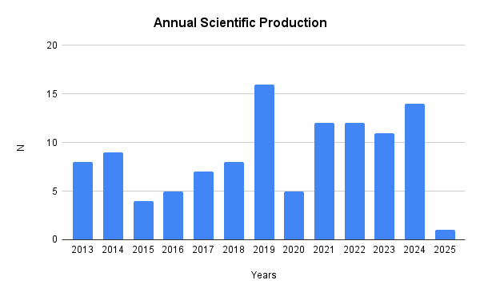
Figure 1 Annual Scientific Production (2013–2025)
- Journals with the Highest Scientific Output
The journals with the highest volume of publication between 2013 and 2025, Table 4 shows that Frontiers in Psychology leads with 21 publications, followed by Psychology of Sport and Exercise with 15. In third place is Cuadernos de Psicología del Deporte with 10 articles, while both the International Journal of Sport and Exercise Psychology and the Revista de Psicología del Deporte each report six publications. These results highlight the predominance of English-language journals as the main platforms for disseminating knowledge in this field, although some participation from Spanish-language journals is also observed, albeit with a lower volume.
Table 4 Journals with the Highest Number of Published Articles (2013–2025)
Journal | Frequency
Frontiers in Psychology | 21
Psychology of Sport and Exercise | 15
Cuadernos de Psicología del Deporte | 10
International Journal of Sport and Exercise Psychology | 6
Revista de Psicología del Deporte | 6
Journal of Applied Sport Psychology | 4
Perceptual and Motor Skills | 4
Revista Iberoamericana de Psicología del Ejercicio y el Deporte | 4
Personality and Individual Differences | 3
Psychology Research and Behavior Management | 3
- Collaboration
This indicator examines cooperation among countries, affiliations, and institutions in scientific production. Table 5 presents the countries with the highest frequency of international collaborations during the period analyzed. France and the United Kingdom lead, each recording seven joint publications with Germany. The United Kingdom–France collaboration ranks second, with four co-authored articles. Canada maintains three joint publications with the United States.
Among Spanish-speaking countries (see Appendix C), Spain stands out with two collaborations each with Colombia and Mexico, and one with Chile and Ecuador. Ecuador also participates in collaborations with France and Germany, while Mexico maintains links with Colombia, Iran, and Poland.
Table 5 International Collaboration by Country (2013–2025)
Country Collaboration | Frequency
France – Germany | 7
United Kingdom – Germany | 7
United Kingdom – France | 4
Canada – United States | 3
United Kingdom – United States | 3
Spain – Colombia | 2
Spain – France | 2
Spain – Germany | 2
Spain – Mexico | 2
Spain – United States | 2

- Institutional Affiliations
The main institutional affiliations between 2013 and 2025, Figure 2 shows that the University of Toronto leads with 10 publications, followed by the German Sport University and the University of Almería, each with six. The German Sport University Cologne and the University of Niš both recorded five publications. These results reveal a significant concentration of scientific production in English-speaking universities, underscoring their predominant role in the development and dissemination of knowledge within this field.

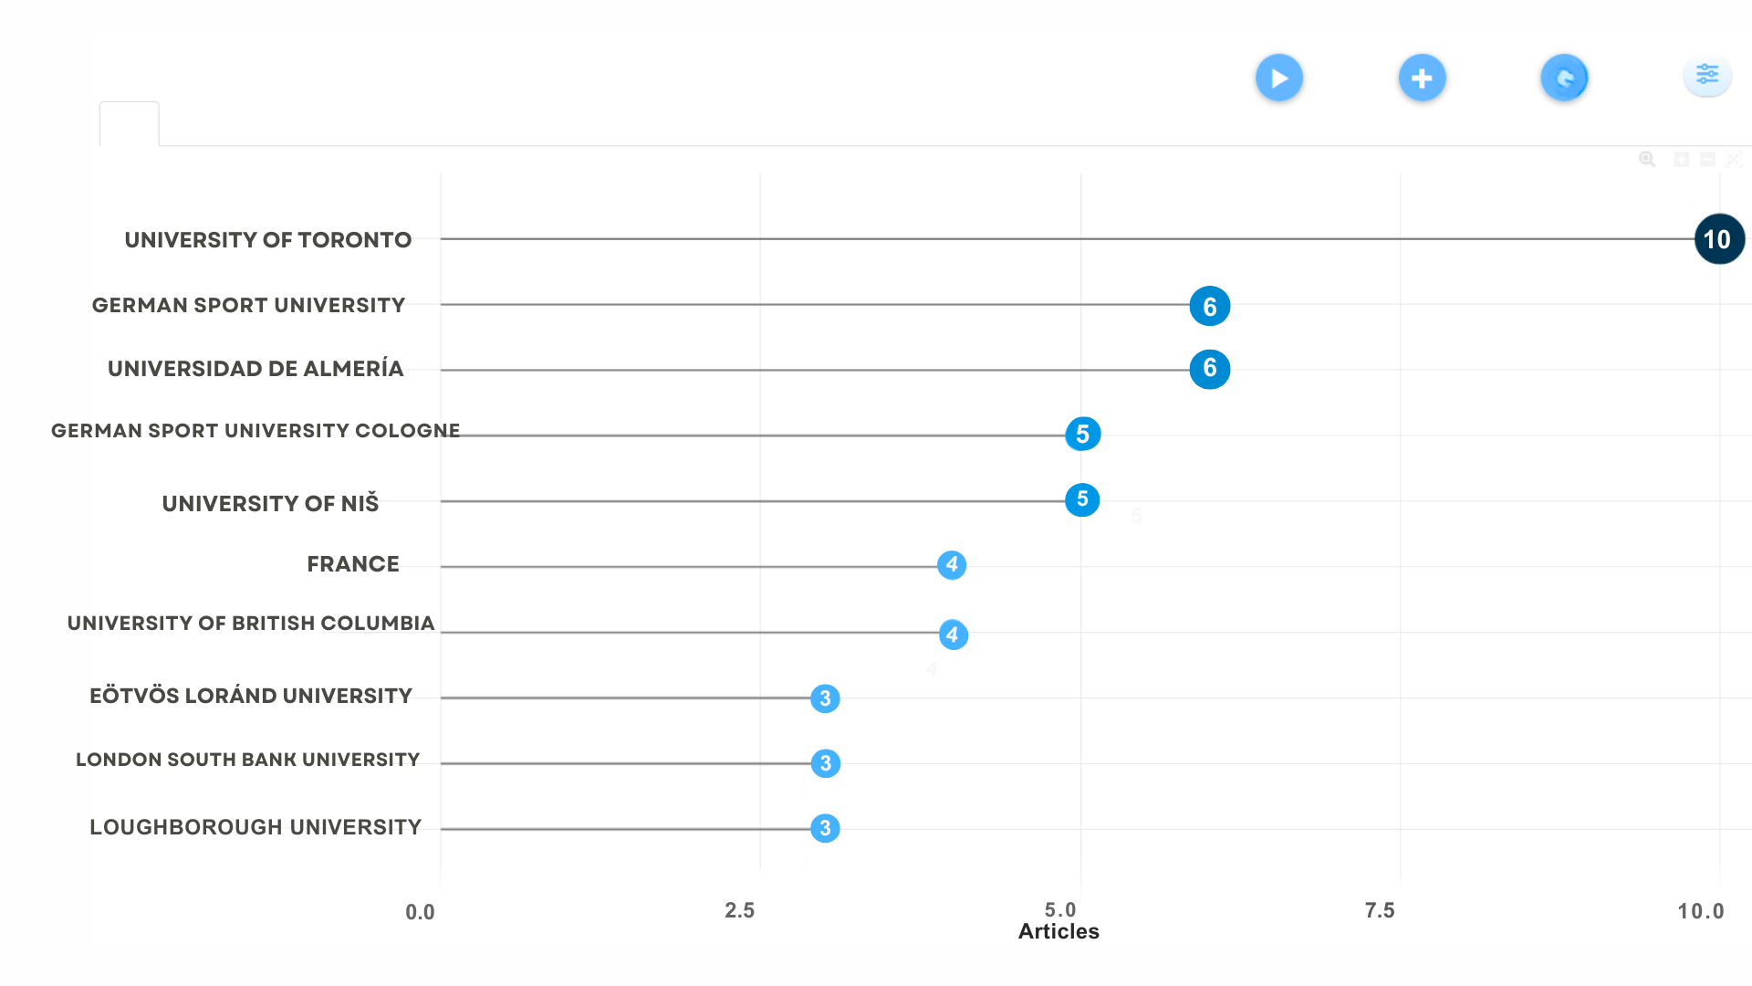
Figure 2 Most Relevant Institutional Affiliations (2013–2025)
Institutions with the highest levels of collaboration (Figure 3), the colored nodes represent associations, and the size of each circle indicates the intensity of shared production through co-authorship. The most prominent node corresponds to the University of Toronto, which leads a consolidated cluster with other Canadian institutions such as the University of Alberta, the University of British Columbia, and the University of Saskatchewan. Another major cluster centers around the German Sport University, which collaborates with European institutions—particularly British and French universities such as Bournemouth University, Université de Rouen, and Université de Caen.
In the Spanish-speaking sphere, a cluster is led by the University of Almería, in collaboration with the University of Coimbra and other nearby institutions, as well as a network that includes the National Autonomous University of Mexico, the University of Deusto, and the Andalusian Center of Sport Medicine (CAMD). These findings suggest that scientific collaboration is structured around geographic, linguistic, and academic factors, revealing the consolidation of strategic alliances built upon shared interests and research lines.
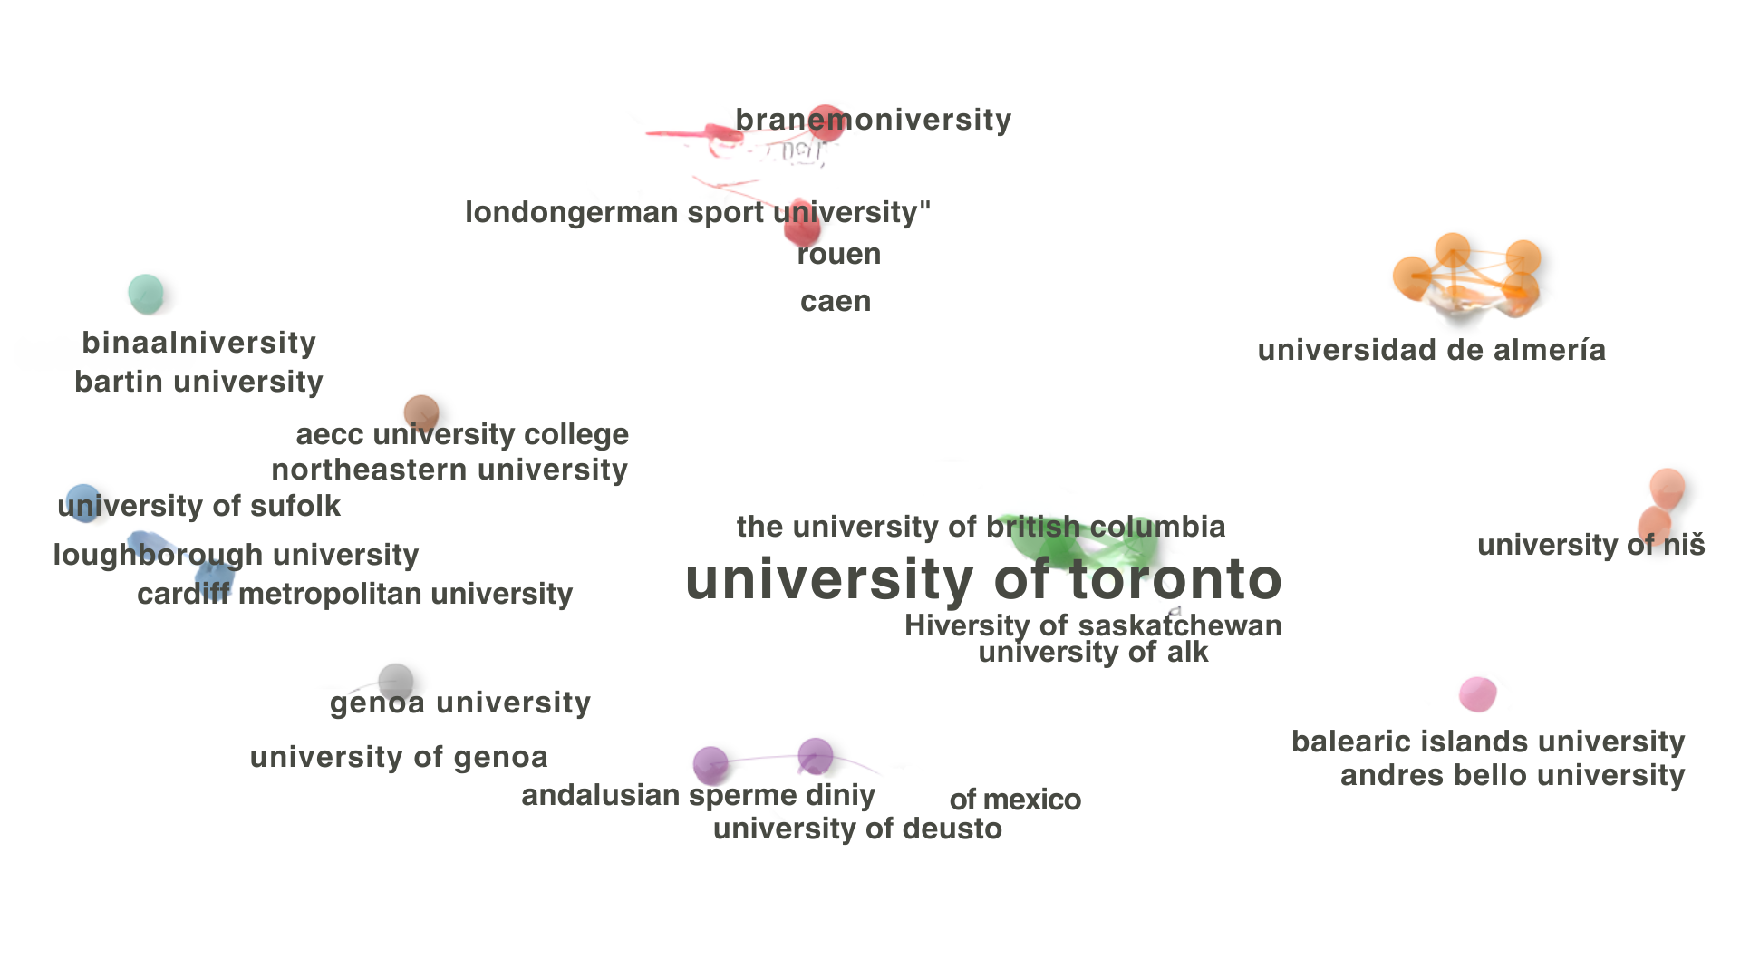
Figure 3 Institutional Collaboration Network (2013–2025)
- Visibility and Impact
The visibility and impact indicator refers to the number of citations received by the journals in the corpus, considering their international presence. As shown in Table 6, Psychology of Sport and Exercise ranks first with 12 citations, followed by Frontiers in Psychology (10) and Cuadernos de Psicología del Deporte (7). The Revista de Psicología del Deporte (5) and the International Journal of Sport and Exercise Psychology (4) occupy the subsequent positions.
These results demonstrate that English-language international journals concentrate the highest proportion of highly cited publications on emotional intelligence applied to sport, underscoring their central role in the dissemination and consolidation of knowledge in this field
Table 6 Most-Cited Journals (2013–2025)
Journal | Frequency
Psychology of Sport and Exercise | 12
Frontiers in Psychology | 10
Cuadernos de Psicología del Deporte | 7
Revista de Psicología del Deporte | 5
International Journal of Sport and Exercise Psychology | 4
Perceptual and Motor Skills | 4
Journal of Applied Sport Psychology | 3
BMC Psychology | 2
Cognition and Emotion | 2
Journal of Sport and Exercise Psychology | 2

- Form and Content
The form and content index analyzes the most relevant themes within the corpus by examining keywords, thematic evolution, and the co-occurrence of terms related to emotional intelligence in sport. This analysis allows for the identification of consolidated research areas and emerging topics. Figure 4 illustrates the distribution of these themes, where circle size indicates relative importance, and overlapping areas reflect conceptual relationships.
In the upper right quadrant (motor themes) are the core topics: emotional intelligence, motivation, athletes, emotions, sport psychology, and sports. The lower right quadrant (basic themes) includes emotion, sport, and coping, along with growing topics such as emotion regulation, adolescents, and team sports. The upper left quadrant (niche themes) contains more specialized concepts such as runners, martial arts, high performance, and emotional skills. Finally, the lower left quadrant (emerging themes) features basketball, indicating a potential research gap for future studies.
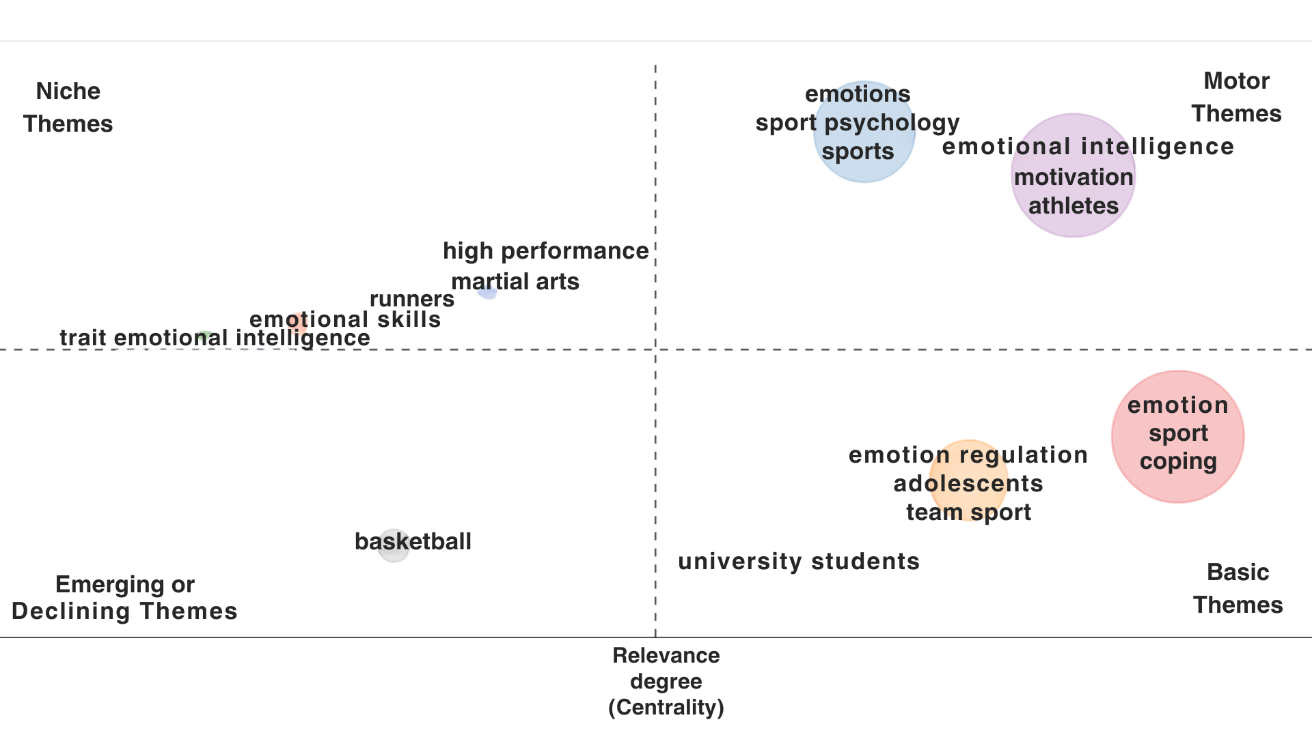
Figure 4 Thematic Clusters and Conceptual Relationships in Emotional Intelligence and Sport (2013–2025)
The keyword analysis for articles published between 2013 and 2025 (Figure 5) shows that emotional intelligence is the most frequent term, with 42 mentions, followed by emotion (36) and sport (33), underscoring their centrality within the scientific output. Intermediate-frequency terms include emotion regulation, coping, emotions, and motivation (8–9 mentions), whereas affect, athletes, and competition appear 6–7 times. Together, these keywords reflect the field’s main thematic lines, with an emphasis on emotional competencies, affective management, and their relationship to sport practice.
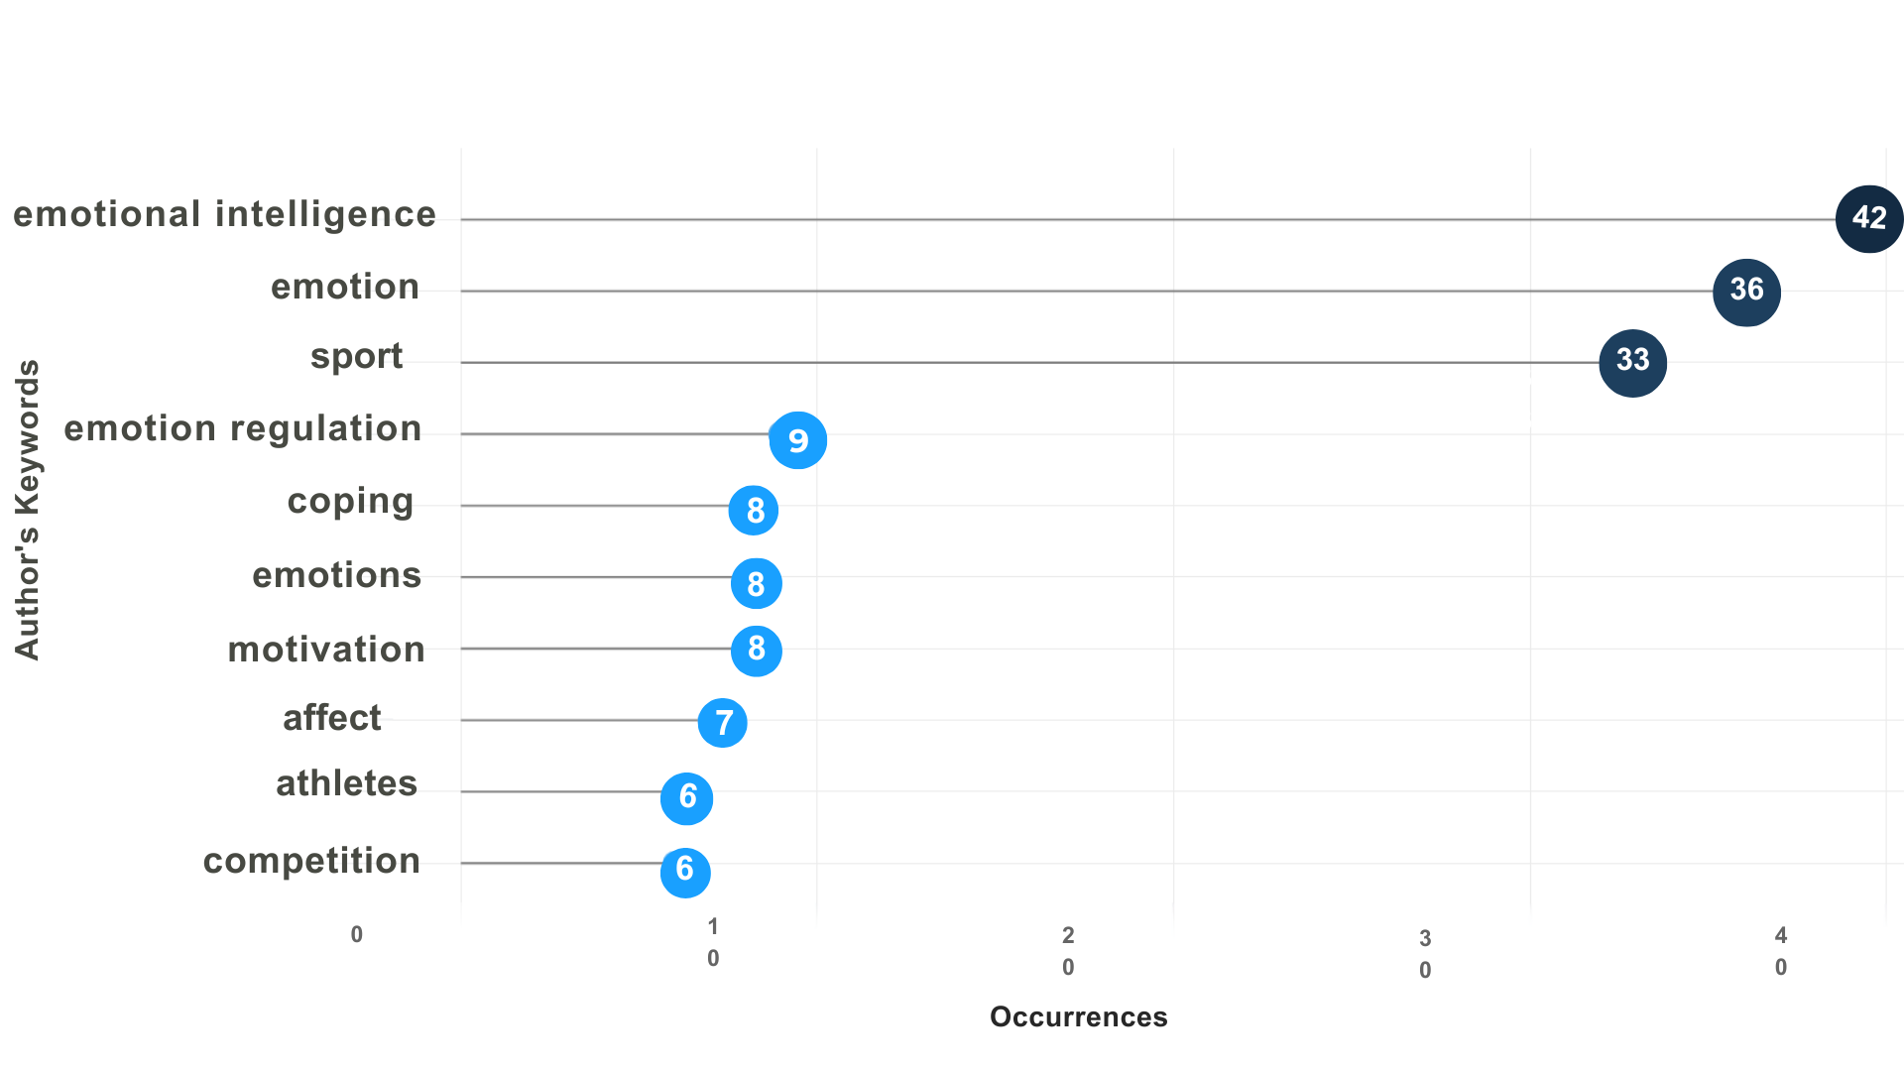
Figure 5 Keyword Frequencies (2013–2025)
Figure 6 compares the thematic evolution of research on emotional intelligence in sport across 2013–2019 and 2020–2025. Colored rectangles group predominant themes and arrows indicate conceptual linkages, allowing identification of continuities, transformations, and new lines of inquiry.The term emotional intelligence (red) remains the central axis in both periods, linked to emotion regulation, emotions, sport psychology, and motivation.
Emotion (light blue) and emotions (green) persist as key topics, while sport psychology (purple) maintains temporal continuity. In contrast, competition and physical activity lose visibility, showing no connections to the second period. Finally, the emergence of adolescent (brown) in 2020–2025 suggests a population-focused shift toward emotional development in earlier stages of sport participation.
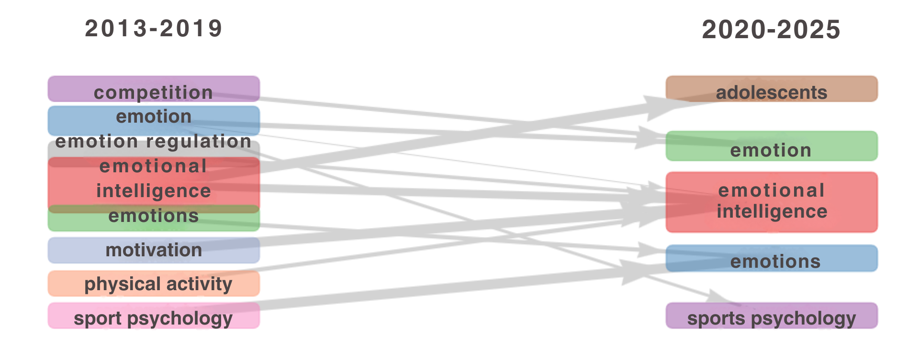
Figure 6 Thematic Evolution: 2013–2019 vs. 2020–2025
Figure 7 displays the co-occurrence of the most frequent terms from 2013–2025, where nodes represent keywords (with size indicating frequency) and edges represent co-appearances (with thickness indicating intensity). Three clusters were identified: a blue cluster linked to emotional intelligence in educational and training contexts—including motivation, emotion regulation, performance, physical education, and university students; a red cluster associated with competitive sport—featuring anxiety, affect, anger, coping, exercise, competition, gender, and COVID-19; and a green cluster centered on sport psychology and psychometrics, focused on assessing emotional variables.
The terms emotional intelligence, emotion, and sport stand out as central axes, with strong connections between emotional intelligence and emotion regulation and between sport and motivation, reflecting sustained interest in how emotional competencies shape athletes’ coping capacity in sport contexts.
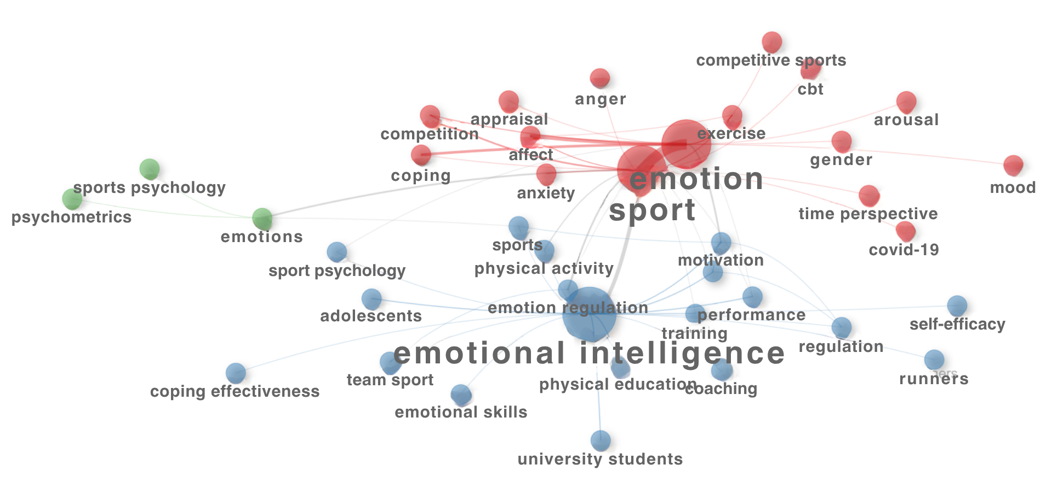
Figure 7 Keyword Co-occurrence Network (2013–2025)
- Theoretical Perspectives on Emotional Intelligence in Sport
This section presents the results of the analysis of the 20 most-cited articles, identifying the predominant theoretical models. As shown in Table 7, Petrides’ Trait Emotional Intelligence model is the most recurrent, cited in four studies, indicating that the conceptualization of EI as a personality trait predominates in sport literature.
Neff’s self-compassion model appears in three articles, reflecting interest in alternative perspectives, whereas the ability model of Mayer and Salovey appears in only one study. These findings suggest a trend toward newer theoretical approaches in research on EI applied to sport.
Table 7 Theoretical Perspectives on Emotional Intelligence in Sport (Top 20 Most-Cited Articles)
Authors (Year) | Title | EI Model | Journal
Laborde, S. (2014) | The role of trait emotional intelligence in emotion regulation and performance under pressure | Trait Emotional Intelligence (K. V. Petrides) | Personality and Individual Differences
Reis, N. (2015) | Self-compassion and women athletes’ responses to emotionally difficult sport situations: An evaluation of a brief induction | Self-Compassion (Kristin Neff) | Psychology of Sport and Exercise
Laukka, P. (2013) | Emotional and motivational uses of music in sports and exercise: A questionnaire study among athletes | Conceptual Model (Terry & Karageorghis) | Psychology of Music
Wagstaff, C. (2013) | Developing emotion abilities and regulation strategies in a sport organization: An action research intervention | Ability Model (Mayer & Salovey) | Psychology of Sport and Exercise
Laborde, S. (2013) | The tale of hearts and reason: The influence of mood on decision making | Mood-as-Input Model (Martin et al.) | Journal of Sport and Exercise Psychology
Zhang, Z. (2022) | The roles of exercise tolerance and resilience in the effect of physical activity on emotional states among college students | Biopsychosocial Model (George Engel) | International Journal of Clinical and Health Psychology
Laborde, S. (2014) | Validity of the trait emotional intelligence questionnaire in sports and its links with performance satisfaction | Trait Emotional Intelligence (K. V. Petrides) | Psychology of Sport and Exercise
Tamminen, K. (2017) | No emotion is an island: An overview of theoretical perspectives and narrative research on emotions in sport and physical activity | Appraisal Theory (Richard Lazarus) | Qualitative Research in Sport, Exercise and Health
Sutherland, L. (2014) | Narratives of young women athletes’ experiences of emotional pain and self-compassion | Self-Compassion (Kristin Neff) | Qualitative Research in Sport, Exercise and Health
Tamminen, K. A. (2016) | Exploring emotions as social phenomena among Canadian varsity athletes | Group/Collective Emotion Theories (Goldenberg) | Psychology of Sport and Exercise
Campo, M. (2016) | Emotional intelligence training in team sports: The influence of a season-long intervention program on trait emotional intelligence | Tripartite EI Model (Nelis) | Journal of Individual Differences
Cowden, R. (2016) | Mental toughness, emotional intelligence, and coping effectiveness: An analysis of construct interrelatedness among high-performing adolescent male athletes | Trait Emotional Intelligence (K. V. Petrides) | Perceptual and Motor Skills
Cárdenas, D. (2015) | The role of mental workload in sport training planning | O’Donnell & Eggemeier Model | Revista de Psicología del Deporte
Mosewich, A. (2019) | Self-compassion in the stress process in women athletes | Self-Compassion (Kristin Neff) | The Sport Psychologist
Laborde, S. (2017) | Trait emotional intelligence questionnaire full-form and short-form versions: Links with sport participation frequency and duration and type of sport practiced | Trait Emotional Intelligence (K. V. Petrides) | Personality and Individual Differences
Tamminen, K. A. (2016) | Interpersonal emotion regulation among adolescent athletes: A Bayesian multilevel model predicting sport enjoyment and commitment | Multilevel Emotion Regulation in Teams (MERAT; Campos) | Journal of Sport and Exercise Psychology
Turner, M. (2019) | Maladaptive schemas as a potential mechanism through which irrational beliefs relate to psychological distress in athletes | REBT (Rational Emotive Behavior Therapy; Albert Ellis) | Psychology of Sport and Exercise
Tamminen, K. (2021) | The effect of self- and interpersonal emotion regulation on athletes’ anxiety and goal achievement in competition | Gross’s Emotion Regulation Model | Psychology of Sport and Exercise
Martínez & Fayos (2013) | Emotional intelligence and sport: Current state of research | Goleman’s Model | Cuadernos de Psicología del Deporte
Note. EI = Emotional Intelligence. Models and journal titles are reported as stated in the original studies. Selection corresponds to the 20 most-cited items within the analyzed corpus.

4. Discussion
The findings from the bibliometric analysis and the systematic review of the 20 most-cited articles on emotional intelligence (EI) in sport, published in psychology journals indexed in Scopus (2013–2025), reveal an irregular annual output, with an average of nine publications between 2013 and 2024 and a single productivity peak, without evidence of sustained growth. This pattern reflects a field still in consolidation.
Martínez and Fayos (2013), Bellón (2020), Rochín and Berrueto (2022), and Albano et al. (2023) concur that, despite the visibility achieved by sport psychology between 2000 and 2010, its development has been constrained by professional tensions and methodological weaknesses, which have hindered continuity in scientific production.
Publication dynamics appear to be influenced by international sporting events. According to Sajad Gholampour et al. (2023), the Olympic Games (London 2012, Rio 2016, Tokyo 2020) and the FIFA World Cups (Brazil 2014, Russia 2018, Qatar 2022) stimulated academic interest in performance, emotion, and sport psychology. In this context, the 2019 surge may be related to the Pan American Games and the start of the Olympic cycle toward Tokyo 2020, which acted as catalysts for research on EI.
After 2020, scientific activity may be linked to preparations for the Paris 2024 Olympic Games—characterized, according to Dominteanu et al. (2025), by the incorporation of artificial intelligence, technological innovations, and environmental considerations—factors that appear to orient new research lines in the area.
Country-level analyses show Spain’s leadership in EI applied to sport, with 57 publications, consolidating its status as a Spanish-speaking reference (Martínez & Fayos, 2013). In addition, Córdova (2017) notes that Spain was the first Spanish-speaking country to institutionalize sport psychology in 1962, reinforcing its historical and current relevance. The United Kingdom ranks second with 29 publications, consistent with Martínez and Fayos (2013), who also placed it in that position for 2001–2012 (11 studies).
This stability is associated with a robust institutional structure oriented toward evidence-based research and training in sport psychology (Winter & Collins, 2015). Canada’s third-place position, with 28 publications, marks a notable advance relative to Martínez and Fayos (2013), who placed it sixth with only three studies; however, Németh et al. (2016) already repositioned Canada third, concentrating 15% of production among the countries analyzed. This growth is linked to national public policies that promote physical activity, sport, and health (Public Health Agency of Canada, 2020).
Regarding the journals with the greatest publication volume, Frontiers in Psychology leads with 21 articles in the analyzed period. Since its appearance in 2012, it has maintained steady growth due to its broad, multidisciplinary scope that addresses emotions, motivation, and EI in sport (Frontiers in Psychology, 2025).
Psychology of Sport and Exercise, with 15 publications, also shows a prominent presence, in line with Németh et al. (2016), who identify it among four specialized journals that, since the 2000s, increased their periodicity from four annual issues to bimonthly editions. In turn, Cuadernos de Psicología del Deporte records 10 publications, reflecting moderate influence—consistent with Martínez and Fayos (2013), who noted that between 2000 and 2013 the journal did not rank among the most cited or highest-impact outlets.
With respect to scientific collaboration, France leads with seven co-authored publications, followed by the United Kingdom with the same number, while the remaining countries show substantially lower participation (see Appendix C).
This European hegemony aligns with Castillo and Powell (2019), who highlight the leading role of France, the United Kingdom, and Germany in bilateral academic cooperation with Latin America between 2006 and 2015. At the level of institutions and affiliations, Canadian universities form the principal collaboration node, reinforcing Canada’s high scientific productivity indicated by prior sub-indicators.
The University of Toronto stands out, with close ties to the University of British Columbia and the University of Saskatchewan (see Figure 2), a relationship attributable to program offerings in sport psychology and specialized centers for applied research (University of Toronto, 2025). Among Spanish-speaking institutions, the University of Almería (Spain) leads collaborations, confirming Spain’s pioneering role in scientific production on sport (Córdova, 2017).
In terms of affiliations with the highest output, the three most productive institutions coincide with the five leading countries in research and collaboration, reinforcing coherence across sub-indicators: the University of Toronto leads with 10 publications, followed by the German Sport University (Germany) and the University of Almería (Spain).
In the visibility and impact indicator, the three most-cited journals overlap with those with the highest production, evidencing not only volume but also academic recognition. Psychology of Sport and Exercise leads with 12 citations, surpassing Frontiers in Psychology and Cuadernos de Psicología del Deporte. Its primacy, despite lower output, is attributed to its consolidation as a prestigious, specialized journal; publication in English and its trajectory since 2000 have favored its impact on the scientific literature (Németh et al., 2016).
The most salient topics on EI in sport show trending focus on emotions, sport psychology, and sport, as well as EI, motivation, and athletes—consistent with Albano et al. (2023), who highlight an increase in publications on emotions and task-oriented motivation to optimize performance and prevent dysfunctional emotional states.
Among basic topics are emotion, sport, coping, emotion regulation, adolescents, team sports, and university students, reflecting interest in emotional management in formative contexts. Galvis Leal (2022) finds that adolescent athletes show greater emotional self-regulation, while Ubago (2019) and Jacho (2023) confirm positive EI effects in adolescent and university populations.
Niche themes—such as high performance, runners, martial arts, and trait emotional intelligence—indicate the influence of trait EI on physical performance and psychological processes (Cece et al., 2019; Baier et al., 2020; Rodríguez et al., 2021; Leñador et al., 2023). Emerging topics include disciplines such as basketball, reflecting growing interest in team sports. Castro et al. (2018) highlight its positive relationship with EI dimensions, and Rodríguez et al. (2021) note its potential to promote emotional skills that are key to performance and adaptation in sport contexts.
Keyword analyses reveal the predominance of terms such as EI, emotion, sport, and emotion regulation, and coherence with other sub-indicators. This emphasizes a focus on the influence of emotions and their management on athletes’ performance and well-being. Prior studies (Rodríguez et al., 2021; Miranda & Cantú, 2022; Leñador et al., 2023) underscore EI’s impact on performance and coping strategies, consolidating EI as a transversal axis of contemporary sport.
The thematic evolution (Figure 6) shows the persistence of concepts such as EI and emotions, indicating sustained interest in self-knowledge processes in sport (Ubago et al., 2020; Jacho et al., 2023). There is also an expansion toward adolescent populations from 2020 to 2025, underscoring the importance of promoting early intrapersonal competencies (Rodríguez et al., 2021). Terms such as sport psychology and emotion regulation indicate an applied focus on the functionality of emotional management with respect to performance and competitive stress (Castro et al., 2018).
The co-occurrence analysis confirms the persistence of emotion, sport, and EI as central nodes, in line with Martínez and Fayos (2013) and Baier et al. (2020). Thematic clusters linked to motivation, performance, emotion regulation, training, and physical education reinforce EI’s positive impact on performance—especially in training and team sports (Rodríguez et al., 2021; Miranda & Cantú, 2022; Leñador et al., 2023).
Terms such as university students, adolescents, team sport, and physical activity reflect a focus on young populations and educational contexts (Ubago et al., 2019; Jacho, 2023). Concepts such as exercise, competition, anger, gender, and mood indicate interest in psychophysiological and differential factors, supporting EI’s role in managing competitive stress and differences by gender and type of practice (Cece et al., 2019; Sáenz et al., 2022). The emergence of psychometrics signals methodological concern for accurate measurement of the construct, consistent with Khotbi and Brir (2023), who emphasize the need for valid and reliable instruments to assess psychological variables in sport settings.
The review of the twenty most-cited articles shows a preference for Petrides’ trait EI model, consistent with Kopp et al. (2021) on its greater capacity to predict subjective variables such as self-assessed performance. In contrast, the ability model of Mayer and Salovey—while historically relevant—has a lower presence, focusing on the perception, understanding, use, and management of emotions in sport contexts (Leñador et al., 2025).
Neff’s self-compassion model appears in studies on self-kindness, empathy, mindfulness, and coping with failure, contributing to reductions in anxiety and to emotional recovery following sport failures (Terzioğlu & Çakir, 2024; Zhang et al., 2023). The trait EI model was applied to variables such as stress management, self-confidence, well-being, motivation, coping, and sport psychology, evidencing its utility for analyzing affect regulation and performance under pressure (Kopp et al., 2021). The Mayer–Salovey model was employed in studies of cognitive processes and emotional self-regulation, while self-compassion was linked to strengthening athletes’ well-being and emotional resilience.
Overall, these findings align with the thematic evolution identified in the bibliometric analysis: the centrality of emotional intelligence and its connections with emotion regulation, motivation, and sport psychology reflect the consolidation of EI as both a theoretical and applied axis in sport research. The integration of alternative models, such as self-compassion, also indicates the emergence of new lines oriented toward coping strategies and emotional resilience in contexts of highly competitive pressure.
5. Conclusions
The analysis demonstrates that research on emotional intelligence (EI) in sport has shown an overall declining trend over the past twelve years, although a diverse scientific output continues to emerge across multiple countries and specialized journals. Most studies originate from European and English-speaking contexts; however, the appearance of Latin American research—including studies conducted in Costa Rica—reflects an emerging, albeit incipient, interest that requires further consolidation to achieve greater international projection and visibility.
The characterization of bibliometric indicators revealed a variable pattern, with a peak in 2019 followed by a subsequent decline. Nevertheless, this reduction does not diminish the academic value of the studies, which exhibit a high average number of citations per document and demonstrate the consolidation of international collaboration networks that strengthen scientific exchange and collective knowledge construction.
Thematic evolution revealed a shift from general approaches focused on emotion and sport toward more specific perspectives centered on emotion regulation, applied sport psychology, and the study of targeted populations such as adolescents. This specialization reflects the field’s growing maturity and its capacity to address the specific needs of diverse contexts and population groups.
At the theoretical level, the conception of EI as a personality trait—proposed by Petrides—predominates, linking it to sport-related personality characteristics. However, other relevant perspectives have also emerged, such as Neff’s self-compassion model, theories of emotion regulation, and group management models. The coexistence of these approaches suggests a diverse and evolving field that broadens the potential for new applied research in sport contexts.
This study also identified limitations that constrain the scope of the findings, primarily the scarcity of comprehensive bibliographic material directly examining the relationship between EI and sport, as most studies address its components in a fragmented manner. This highlights the need to strengthen academic production systematically and coherently integrates both domains.
It is recommended that academic institutions promote research lines and outreach projects focused on emotional intelligence applied to sport, addressing motivation, performance, and emotion regulation in competitive contexts, as well as coping processes and specific populations such as adolescents, women, and high-performance athletes. Future work should also include underexplored disciplines such as basketball and martial arts.
Finally, it is imperative that sport psychology programs explicitly incorporate the dimension of emotional intelligence, fostering psychological skill development, encouraging evidence-based research, and promoting applied strategies that enhance both professional practice and the integral development of athletes.

References

- Aguirre, L., & Muñoz, I. (2013). Cienciometría para ciencias médicas: Definiciones, aplicaciones y perspectivas. Investigación en Educación Médica, 2(6), 100–106. https://doi.org/10.1016/S2007-5057(13)72694-2
- Albano, V., Gragera, M., Córdoba, G., & Molina, S. (2023). Práctica deportiva e inteligencia emocional en jóvenes: Revisión sistemática. Cuadernos de Psicología del Deporte, 23(3). https://doi.org/10.6018/cpd.536391
- Aria, M., & Cuccurullo, C. (2017). Bibliometrix: An R-tool for comprehensive science mapping analysis. Journal of Informetrics, 11(4), 959–975. https://doi.org/10.1016/j.joi.2017.08.007
- Arraya Vargas, G., & Salazar Rojas, W. (2001). Inteligencia y rendimiento deportivo: Un estudio sobre la inteligencia emocional. Pensar en Movimiento: Revista de Ciencias del Ejercicio y la Salud, 1(1), 44–49. https://doi.org/10.15517/pensarmov.v1i1.423
- Baier, H., González, H., Alonso-Dos Santos, M., Inzunza, W., & Pozo, V. (2020). Emotions and sport management: A bibliometric overview. Frontiers in Psychology, 11, 1512. https://doi.org/10.3389/fpsyg.2020.01512
- Bar-On, R. (1997). The emotional intelligence inventory (EQ-i): Technical manual.
- Bar-On, R. (2006). The Bar-On model of emotional-social intelligence (ESI). Psicothema, 18, 3–25.
- Bellón, M. (2019). Participación del psicólogo deportivo en el rendimiento de equipos de fútbol competitivos: Una revisión narrativa [Tesis de grado, Universidad Pontificia].
- Bonilla, L. (2019). Intervención psicológica en la selección absoluta de futsala de Costa Rica para el Mundial de Colombia 2016. Revista de Psicología Aplicada al Deporte y al Ejercicio Físico, 4(2), 1–9. https://doi.org/10.5093/rpadef2019e16
- Bravo-Lara, I. (2021). Producción científica sobre las intervenciones psicológicas en el contexto hospitalario mediante los indicadores bibliométricos de artículos científicos en revistas de Estados Unidos e Iberoamérica entre el 2010-2020 [Tesis de licenciatura en Psicología, Universidad de Costa Rica].
- Briones, M. (2016). Psicología en el deporte. Dominio de las Ciencias, 2(3), 323–334. https://doi.org/10.23857/dc.v2i3.143
- Brito, D., Santana, Y., & Pirela, G. (2019). El modelo de inteligencia emocional de Bar-On en el perfil académico-profesional de la FACO/LUZ. Ciencia Odontológica, 16(1), 27–40.
- Cagigal, J. (1979). Deporte, pulso de nuestro tiempo. Nacional Digital.
- Camuñas, A. C., Lluch, J. J. G., & Rubio, P. J. S. (2022). Educación emocional en el balonmano Morvedre. Informació Psicològica, 124. https://doi.org/10.14635/IPSIC.1943
- Castillo, J., & Powell, A. (2019). Análisis de la producción científica del Ecuador e impacto de la colaboración internacional en el periodo 2006-2015. Revista Española de Documentación Científica, 42(1), e225. https://doi.org/10.3989/redc.2019.1.1567
- Castro, M., Zurita, F., Chacón, R., López, J., & Zafra, E. (2018). Emotional intelligence, motivational climate and levels of anxiety in athletes from different categories of sports: Analysis through structural equations. International Journal of Environmental Research and Public Health, 15(5), 894. https://doi.org/10.3390/ijerph15050894
- Chaviano, O., López, E., & Limaymanta, C. (2022). Web of Science como herramienta de investigación y apoyo a la actividad científica: Luces y sombras de sus colecciones, productos e indicadores. E-Ciencias de la Información, 12(1), 134–157. https://doi.org/10.15517/eci.v12i1.46660
- Coimbra, R., Dominski, H., Correia, K., & Andrade, A. (2019). Scientific production in sports science journals: Bibliometric analysis. Revista Brasileira de Medicina do Esporte, 25(1), 88–93. https://doi.org/10.1590/1517-869220192501208554
- Cox, R. (2007). Sport psychology: Concepts and applications (6th ed.). McGraw-Hill.
- Crombie, D., Lombard, C., & Noakes, T. (2009). Emotional intelligence scores predict team sports performance in a national cricket competition. International Journal of Sports Science & Coaching, 4(2), 209–224. https://doi.org/10.1260/174795409788549544
- Desiderio, D., Losardo, R., Bortolazzo, C., van Tooren, J., & Hoyo, E. (2021). Deporte, educación y salud. Revista de la Asociación Médica Argentina, 134(3), 8–14.
- Fallas, N. (2008). Factores psicológicos relacionados con la incidencia y recuperación de las lesiones deportivas en futbolistas [Tesis de grado, Universidad Nacional de Costa Rica].
- Gallegos, M., Pérez, A., Klappenbach, H., López, W., & Bregman, C. (2020). Los estudios bibliométricos en el campo de la psicología iberoamericana: Una revisión metabibliométrica. Interdisciplinaria, 37(2), 95–116. https://doi.org/10.16888/interd.2020.37.2.6
- Goleman, D. (1995). Emotional intelligence: Why it can matter more than IQ. Library of Unviolent Revolution.
- Kopp, A., Reichert, M., & Jekauc, D. (2021). Trait and ability emotional intelligence and its impact on sports performance of athletes. Sports, 9(5), 60. https://doi.org/10.3390/sports9050060
- Martínez, R., & García-Fayos, E. J. (2013). Inteligencia emocional y deporte: Situación actual del estado de la investigación. Cuadernos de Psicología del Deporte, 13(1), 105–112.
- Mayer, J. D., & Salovey, P. (1990). Emotional intelligence. Imagination, Cognition and Personality, 9(3), 185–211. https://doi.org/10.2190/DUGG-P24E-52WK-6CDG
- Mon, D., Blanco, C., Acebes, J., Rodríguez, G., Marquina, M., Martín, A., De la Rubia, A., Martínez, C., Mallén, J., & Garrido, M. (2023). Emotional intelligence in Spanish elite athletes: Is there a differential factor between sports? Sports, 11(8), 160. https://doi.org/10.3390/sports11080160
- Muñoz, J., Herrera, E., Santisteban, A., & Cobo, M. (2020). Software tools for conducting bibliometric analysis in science: An up-to-date review. Profesional de la Información, 29(1), 1–20. https://doi.org/10.3145/epi.2020.ene.03
- Raudales, E. (2022). Estudio bibliométrico de la producción científica sobre inteligencia emocional en la base de datos Scopus. Experior, 1(2), 174–184. https://doi.org/10.56880/experior12.6
- Rodríguez, G., Blanco, C., Díaz, I., & Acebes, J. (2021). Emotional intelligence of undergraduate athletes: The role of sports experience. Frontiers in Psychology, 12, 1–8. https://doi.org/10.3389/fpsyg.2021.609154
- Salovey, P., & Mayer, J. D. (1990). Emotional intelligence. Imagination, Cognition and Personality, 9(3), 185–211. https://doi.org/10.2190/DUGG-P24E-52WK-6CDG
- Thorndike, E. (1920). Intelligence and its uses. Harper’s Magazine, 140, 227–235.
- Ubago-Jiménez, J. L., González-Valero, G., Puertas-Molero, P., & García-Martínez, I. (2019). Development of emotional intelligence through physical activity and sport practice: A systematic review. Behavioral Sciences, 9(4), 44. https://doi.org/10.3390/bs9040044
- Weinberg, R., & Gould, D. (2010). Foundations of sport and exercise psychology (6th ed.). Human Kinetics.
- Williams, J. (1991). Psicología aplicada al deporte. Biblioteca Nueva.
- Winter, S., & Collins, D. (2015). Where is the evidence in our sport psychology practice? A United Kingdom perspective on the underpinnings of action. Professional Psychology: Research and Practice, 46(3), 175–182. https://doi.org/10.1037/pro0000014
- Zhang, N., Huang, J., & Yao, J. (2023). Athletes’ self-compassion and emotional resilience to failure: The mediating role of vagal reactivity. Frontiers in Psychology, 14, 1192265.

